All Dependencies we've currently have used is

1. Link : https://nodejs.org/en/

Description: Node.js is an open source cross-platform Javascript runtime environment

Initial Steps for instantiating/building the project to have React files

1. npm init react-app reactjs (Professor and TA do not need to do this as the dependencies and libraries are already implemented and installed in the project.)

To run the build process to create an executable version of the product.

1. Go to Link:https://github.com/HelianthusNS/Coen174
2. Then we have to download the project from Github, you can do this by pressing the green <> Code button on the github link and downloading the zip file.
3. After everything is downloaded, we can go into the the directory and then cd into the folder .\jamify\
4. In the folder type the command: npm start
5. Now it will say that you

Local: <http://localhost:3000>

On Your Network: <http://192.168.56.1:3000>

1. Now you can visit <http://localhost:3000> to check the build. This will be our first unit testing infrastructure and from seeing this our logo you can see that our smoke test verified that the testing infrastructure is working.



Figure 1: Our logo

* A link to the unit testing framework you're using
* The source code of the first test you wrote

import logo from './logo.svg';

import './App.css';

function App() {

return (

<div className="App">

<header className="App-header">

<p> Jamify Testing </p>

<img src="https://i.imgur.com/upAgTQO.png"/> <a href="home.js"> Home </a>

<a href="home.js"> Home </a>

<img src={logo} className="App-logo" alt="logo" />

<p> Edit <code>src/App.js</code> and save to reload.</p>

<a

className="App-link"

href="https://reactjs.org"

target="_blank"

rel="noopener noreferrer">

Learn React

</a>

</header>

</div>

);

} export default App;

* A screenshot of, or copy-pasted text from, your dashboard / test report (showing that you've got at least one passing test). Most test runners will create a report for you that shows which tests are passing and failing automatically.

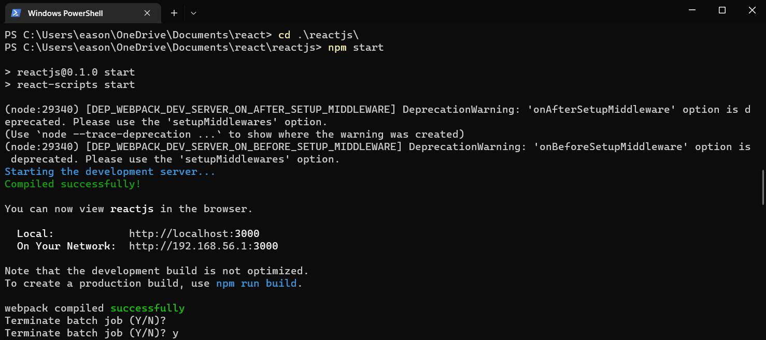

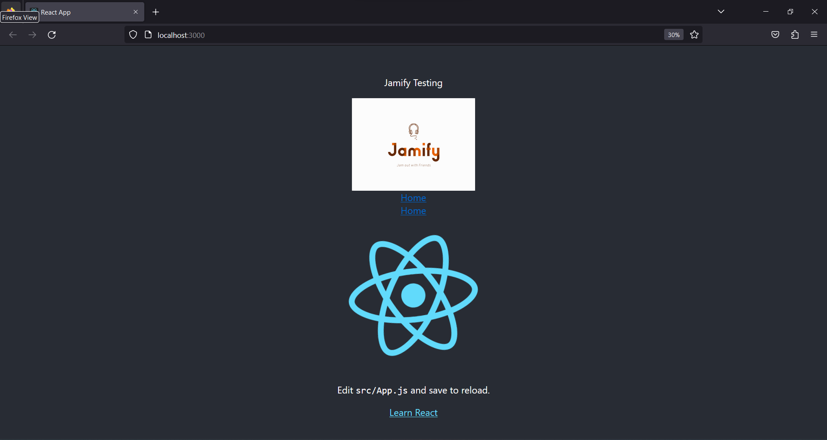

Notes_______________________________________________________________________

: npm and init are scripts in the package.json files.

To consistently create updates through branching:

Consult this link: <https://www.youtube.com/watch?v=e2IbNHi4uCI&ab_channel=freeCodeCamp.org>

____________________________________________________________________________